**2014**

Western Mass Climbers’ Coalition

25 Parkview Dr. South Hadley MA

12/1/2014

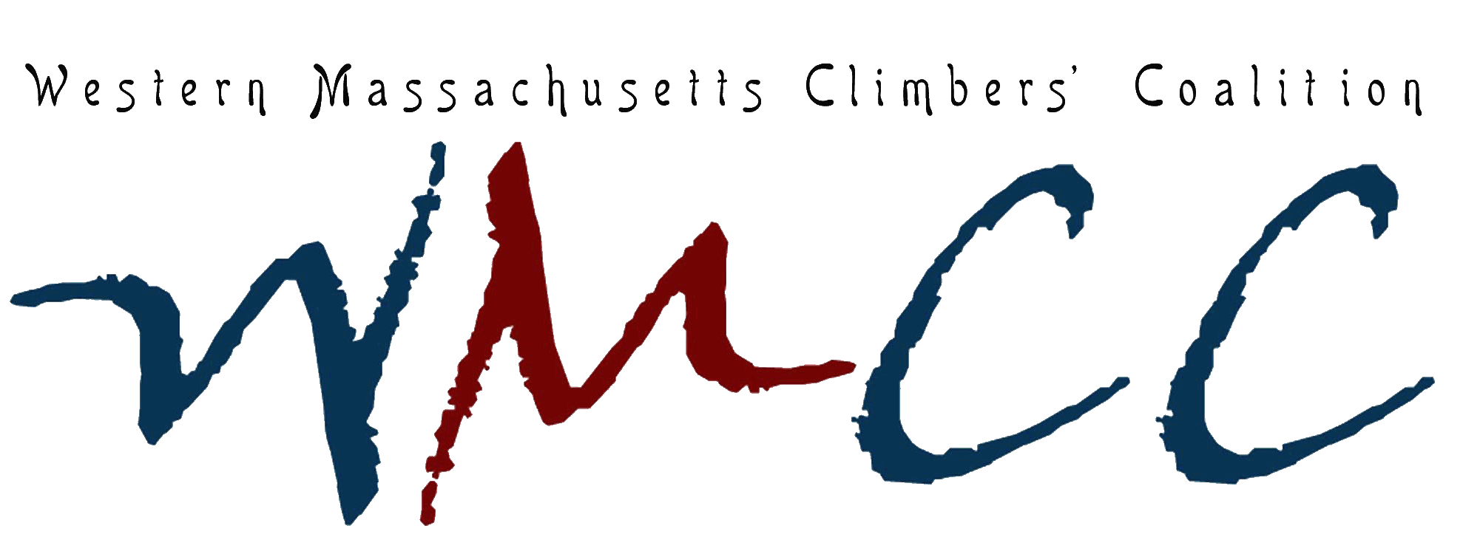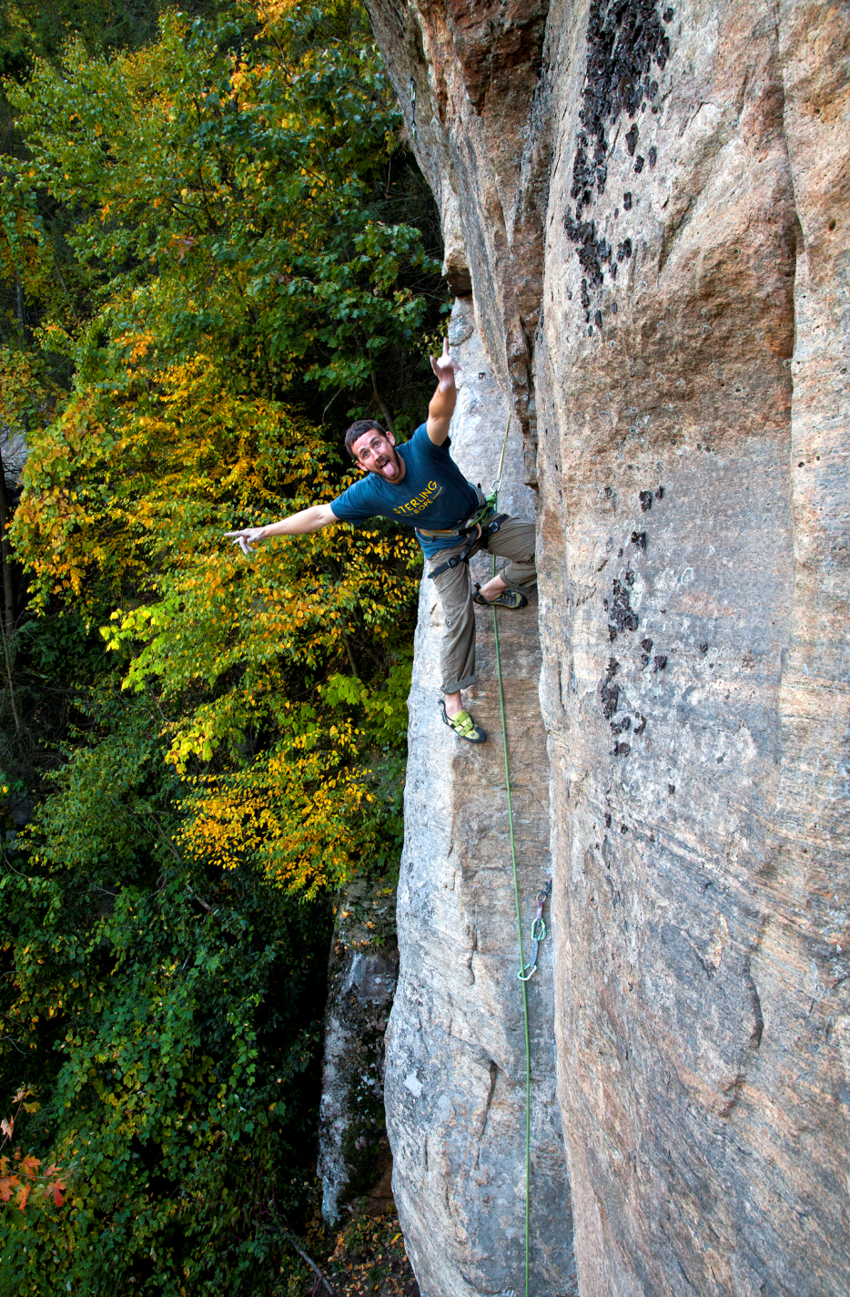

Improvements to Farley Access Project Report

**Project Summary**

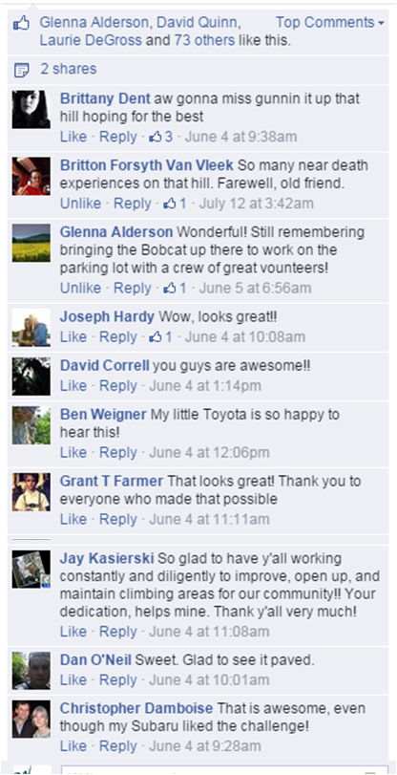

Figure 1: Facebook comments regarding the freshly paved lot

In 2007, with the help of the Access Fund, the WMCC purchased property at the base of Farley Ledge to protect against potential development and to construct a public parking lot to provide access to the cliff and trail system. As Farley’s popularity has grown for both climbers and the general public, necessary improvements to the parking lot became critical to alleviate concerns about erosion, inaccessibility and roadside safety. The goal of this project was to install a stabilized entrance to the public parking lot to sustain access at Farley Ledge.

Early efforts to stabilize the slope by regrading and installing waterbars by Adopt-a-Crag volunteers proved futile. A long term solution was required for continued access as well as for the safety of Farley’s users and neighborly traffic. The funds awarded by the Access Fund were used to pave the steep and deeply-rutted gravel driveway to ensure long lasting access. This project represents a proactive resource management strategy that benefits the experience and improves safety for all users of Farley Ledge. The funds from this grant were matched through WMCC membership and fundraising dollars.

The WMCC contracted a local paving company to complete the task. The lot was temporarily closed for access for 24 hours. The results were immediately apparent and our community was thankful!

**The WMCC and our entire community are grateful to the Access Fund for this grant of $2,500 and continuing to support our ongoing mission!**

**Expense Report**

Excavating and Paving $4,335.00

Granite Curbstone $194.00

Volunteer hours (8)

**Total expense $4529.00**

**Gallery**

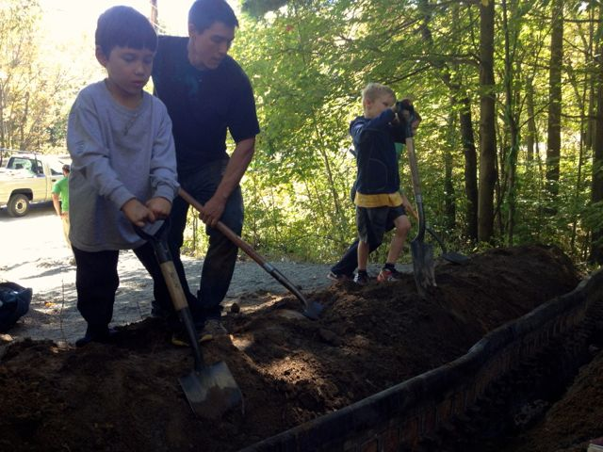

Figure 2: Previous Adopt-A-Crag events sought to improve the driveway by regrading and installing measures to reduce erosion. While beneficial, these improvements did not result in a long term solution that could withstand the increasing visitor numbers and extreme weather fluctuations experienced in the northeast.

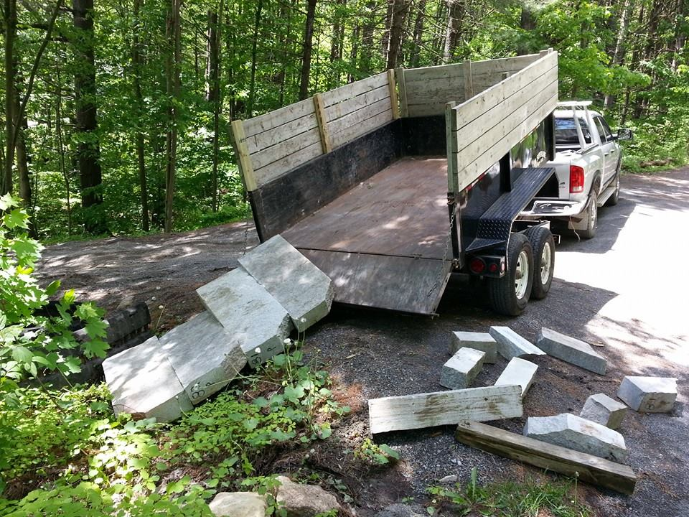

Figure 3: WMCC volunteers deliver granite curbstone to the lot in preparation for the pavers.

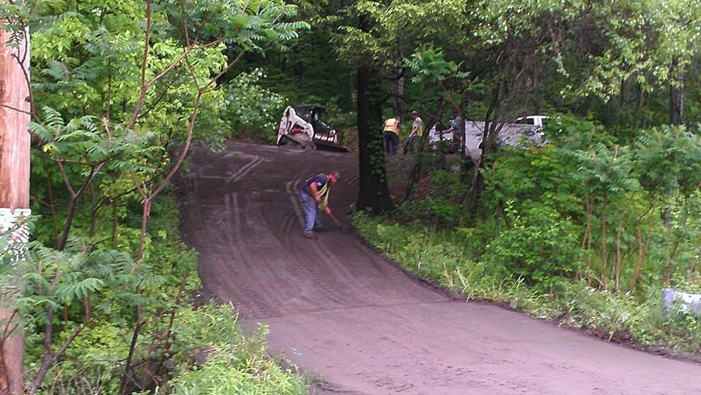

Figure 4: The excavators at work

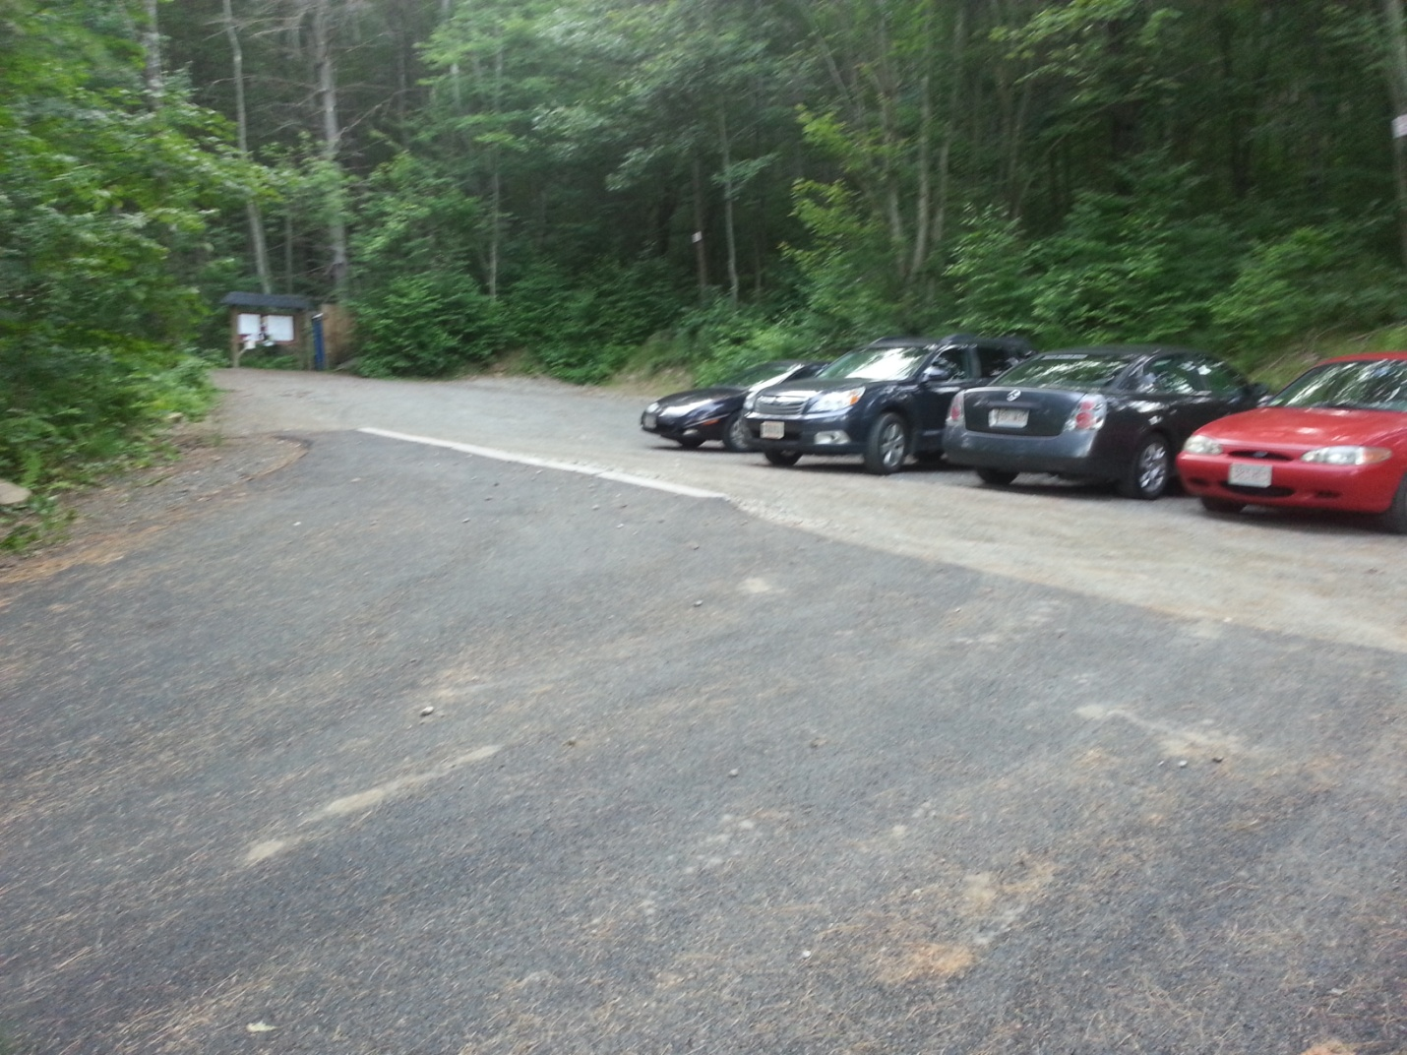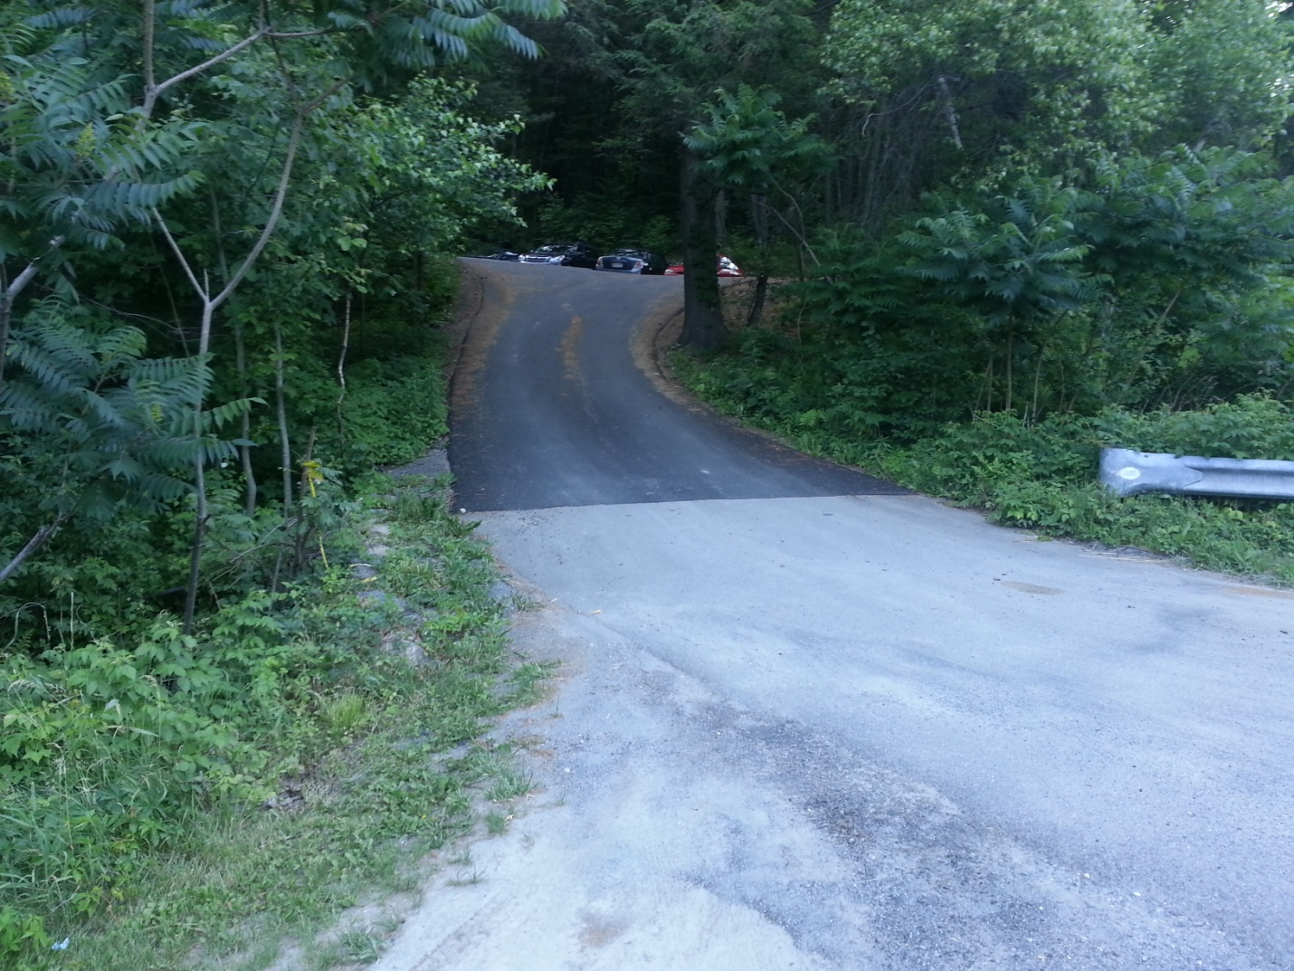

Figures 5a & b: The finished product!